EXP 14
Aim
To perform image transformation using a homography matrix.
Procedure
- Import OpenCV and NumPy.
- Read the image.
- Define matching points.
- Compute the homography matrix.
- Display the transformed image.
Code
import cv2
import numpy as np
img = cv2.imread("image1.png")
pts1 = np.float32([[50,50],[300,50],[50,300],[300,300]])
pts2 = np.float32([[10,100],[250,50],[100,300],[280,280]])
H, status = cv2.findHomography(pts1, pts2)
result = cv2.warpPerspective(img, H, (img.shape[1], img.shape[0]))
cv2.imshow("Original", img)
cv2.imshow("Homography", result)
cv2.waitKey(0)
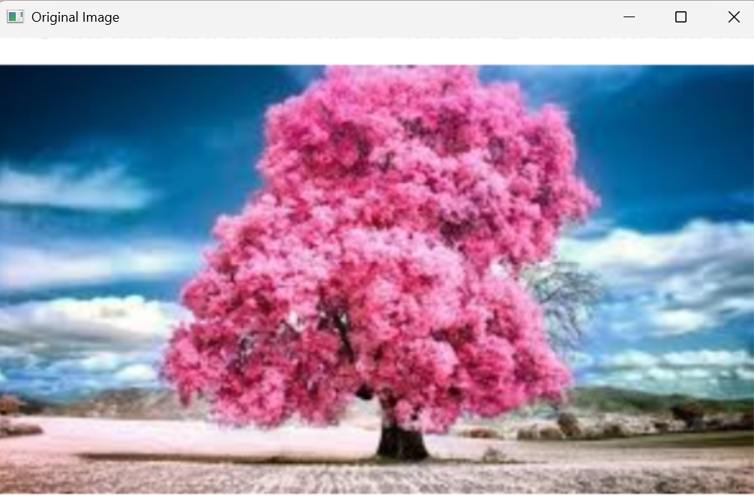
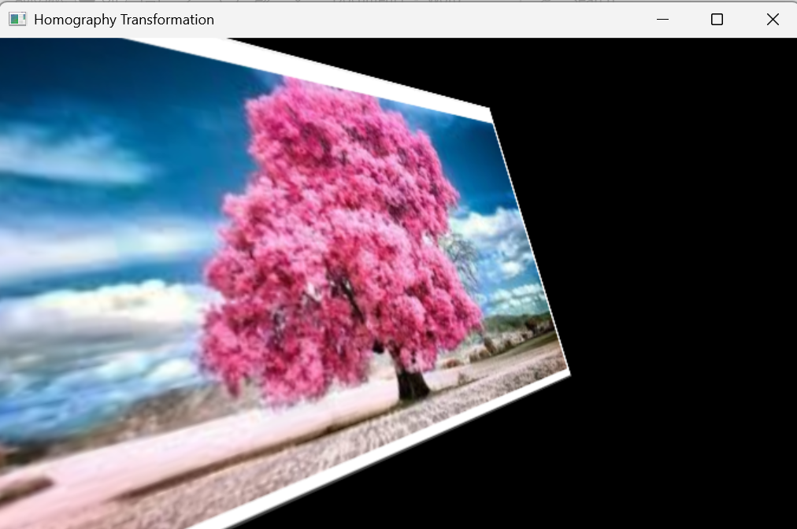
cv2.destroyAllWindows()

